Chapter 6, Problem 55.

Find L_{eq} in each of the circuits of Fig. 6.77.

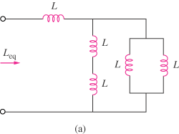

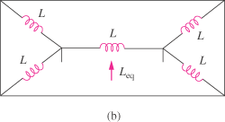

Figure 6.77
For Prob. 6.55.

